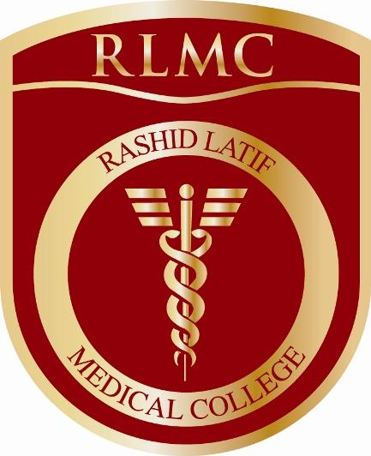

One Snap
1” X 1”
Rashid Latif Medical College
Library
Membership form for Faculty/Administration/Staff

Name: _______________________ Father’s Name: _____________________

CNIC: __________________________________________________________
(Please tick one)

Department: Anatomy
Name and no. of courses allotted:
Physiology
__________________________
Biochemistry
__________________________
Pathology
__________________________

Forensic Medicine

Pharmacology

Medicine

Other Department _______________________________

Staff

Status: Permanent Visiting

Designation: _____________________________________________________

Address: _____________________________________________________

_____________________________________________________

Phone Res: _______________________Cell No: _______________________

E-Mail: _____________________________________________________

________________________
Signature of Library Member ________________
Head of Department

For office use only
Membership ID _________________
Approved/Not approved

_______________________ ___________________
Chairman Library Committee Incharg Library

